**Data Breach Avoidance Based on Honeypot Strategy.**

**Domain: Information Security**

**ABSTRACT**:

A **data breach** is an event where information is stolen or attained from a system without the knowledge or authorization of the system’s owner. This can be a serious concern for organizations that involve losing sensitive, proprietary, or confidential information such as credit card numbers, customer data, or trade secrets. With the right and smart application of Computer science aptitude, Data breaches cannot only be avoided but also helps understand attackers’ moves. One such strategy is Honeypot. This strategy involves maintaining a sacrificial database that’s intended to attract cyberattacks. It mimics a target for hackers and uses their intrusion attempts to gain information about cybercriminals and the way they are operating or to distract them from other targets.

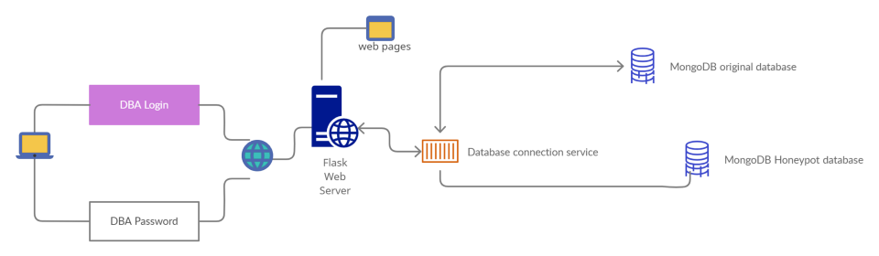System Design

Advancements that can be made to the project:

Use SSH connection to access the data instead of MongoDB. (looks more close to reality)

**Modules:**

>MongoDb data load script

>Web pages

>Main data breach avoidance script

>Session analyzer